Full Stack Engineer Coding Challenge

**Objectives**

This coding challenge is designed to assess a candidate’s level of experience with building a full stack web application. If you have any questions about the coding challenge or any requirements, please feel free to reach out to Mike at [michael.dere@lightfeather.io](mailto:michael.dere@lightfeather.io). Make sure to give yourself a generous amount of time to complete the challenge.

**Rules of Submission**

1. This challenge must be completed in under 48 hours.
2. Your code and any assets must be version controlled with Git.Your submission must include a hyperlink to a github.com repository that you have pushed your project to.
3. The github project should have a README file that includes instructions on anything that would need to be done to **install and run** your submission.
4. Submit your code using the google form here: <https://forms.gle/DNaQn2S9VGueSACdA>.

**Overview**

For this challenge, you will be building a simple form that will populate with data from an API endpoint. After all validation on the form has been complete, the form response will be submitted to another API endpoint. You will also be implementing this simple API which provides a list of supervisors and accepts a registration to receive notifications from a given supervisor.

### Client Specifications

Please build a form that allows for a team member to register for notifications from their supervisor through email or phone *(for the purposes of this challenge, we will not be building out the email or phone functionality, but we do want to capture the data that would be necessary).*

Your form must be able to perform the following functions:

* Retrieve a list of supervisors and display in a dropdown from:   
  GET /api/supervisors.
* Capture the following fields:
  + First Name
  + Last Name
  + Email (if preferred)
  + Phone number (if preferred)
  + Supervisor
* Submit form information to the following endpoint:  
  POST [/api/submit](https://6099a4760f5a13001721985c.mockapi.io/api/submit)
* Please add validation to the following fields:
  + Name fields are required and must only contain letters, no numbers.
  + Either an email or phone number must be provided depending on preference
    - Apply standard email + phone validation for these two fields

*Styling note: Your form can look similar to the mockup provided, but we will not be grading on specific fonts, colors, margins, padding, etc. unless otherwise stated.*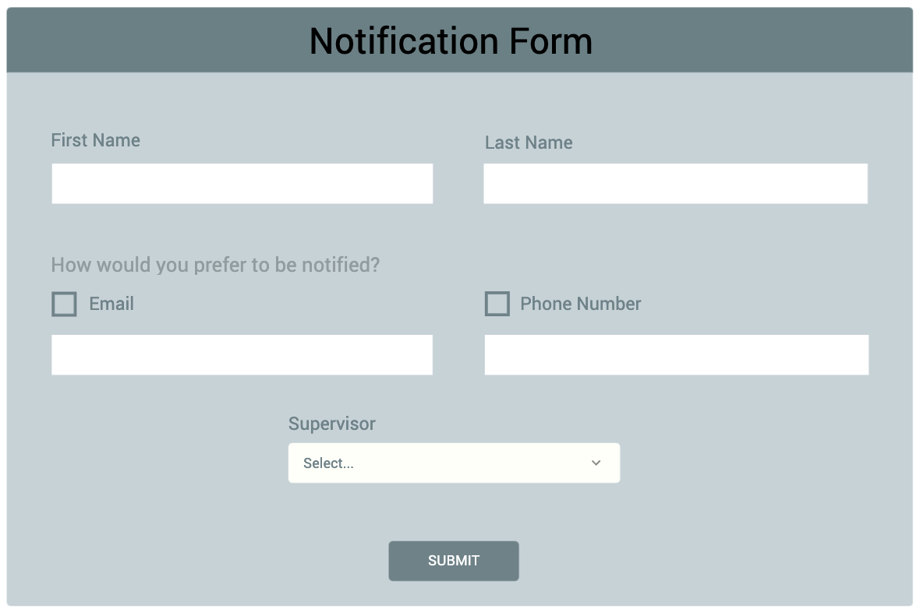

### Server Specifications

Please build an application that exposes an API that allows an application to retrieve a list of supervisors and submit personal information.

Your application must include the following endpoints:

* GET /api/supervisors
  + When this endpoint is hit, a call is made to GET <https://609aae2c0f5a13001721bb02.mockapi.io/lightfeather/managers> to pull down a list of managers.
  + The endpoint should take the mockapi response payload and format it to return:
    - A list of supervisor strings formatted as follows:  
      “{jurisdiction} - {lastName}, {firstName}”
    - Supervisors should be sorted in alphabetical order first by jurisdiction, then by lastName and firstName.
    - Numeric jurisdictions should not be included in the response.
* POST [/api/submit](https://6099a4760f5a13001721985c.mockapi.io/api/submit)
  + The endpoint should accept the following information:
    - First Name
    - Last Name
    - Email (optional)
    - Phone number (optional)
    - Supervisor
  + When the response is received, it should be printed to the console.